**User Manual of UNDP Legislative Tracking Document**

This manual define that how to operate UNDP software. UNDP software is developed for the Legislative Tracking Document. The main functionality of the software is to add a new bill, forward it to houses and commissions, shows the current position of bill and the overall flow of bill

First of all when you install the UNDP software and start the application, it set the username and password of the administrator of the Sql Server as “UNDP_2009” and Password “UNDP_2009”. This is the default username and password, and it is necessary when you installs the sql server and attach database you must create a user name and password as mention above. In case if you change the Username and Password of your database administrator then you may set it manually by clicking on the setting button on the login form. And then give the new Username and password. And then you may connect using your username and Password. The screen shot of the setting form is given below. In the following form just give the Username and Password of the Sql Server Admin and Press Save button it will be saved in your Registry. If it is correct username and Password then it is not necessary to give every time but only set once after changes.

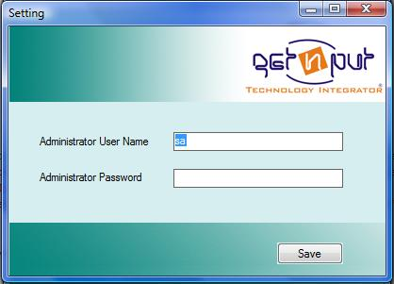

**Login Screen:**

This screen is used in the software to enter if you are the valid user the screen shot of login form is

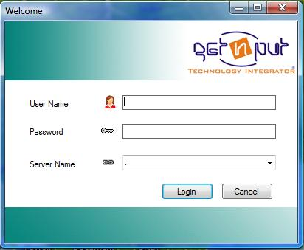

Here the user must enter the valid user name and password provided by the Administrator. And in the Server name combo box enter the server Name or IP on which your Sql server database is installed and configured. After authentication the following main screen is shown

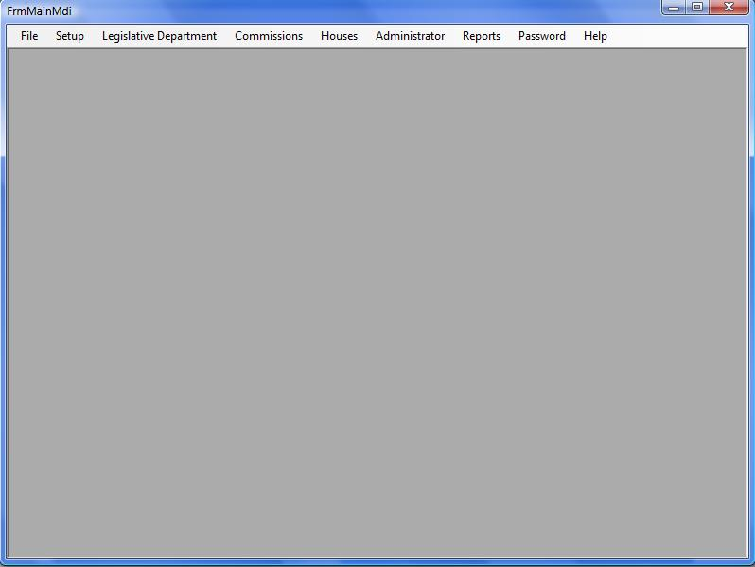

This screen is basically shown to Administrators and the other Group member has the menus according to his Rights. In the above form different menus are shown each menu has further sub menu, by clicking on it shows the appropriate form.

At the first time user/ Administrator must set the setup .i.e the houses, Commissions, Departments, All Status of the Bill etc

Now how to operate the houses, Commissions, Departments, Status form it is defined below

**Houses, Commissions, Departments, Status Forms:**

To operate these forms the procedure is same. To enter a new record first of all press the New Entry button make entry, but keep in mind that the entry in each field is correct that in integer field ie ID etc don’t enter the character. Now to save the new entered record click on the Save button. If record is saved message “record inserted” appears and the new record is shown in the grid. If you want to update the existing record first select it from the list the data about that record is shown in text fields now make changes and click on Update button. If the message like “Record Updated” appears means your record is updated.

Now if you want to delete a record select it in the similar way from the list and press the Delete button. if message like “Record deleted” appears it mean that your record is deleted successfully, but if other message appears it mean this record is used somewhere else so first delete it from that used form and then delete it from here for example if a record is used in the “Forward bill to commissions” form first delete from there and then delete from here. Similarly if you want to search a record follow the hints in the search record field enter the parameter and press enter button your desired record is shown in the grid.

**Houses Form:**

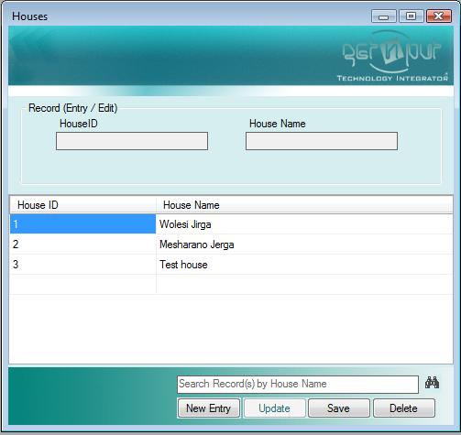

**Commission From:**

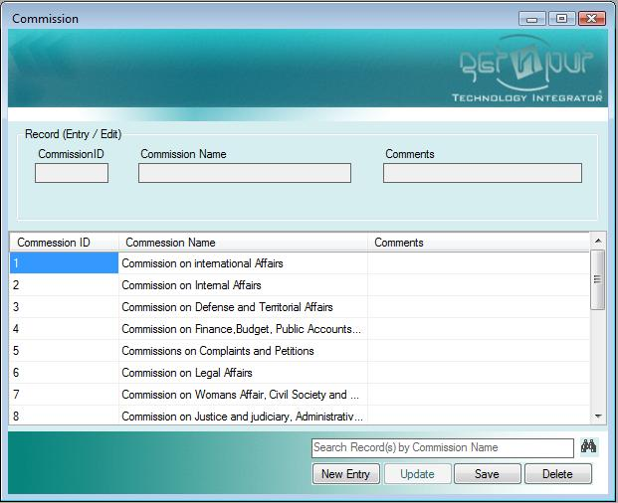

**Department Form:**

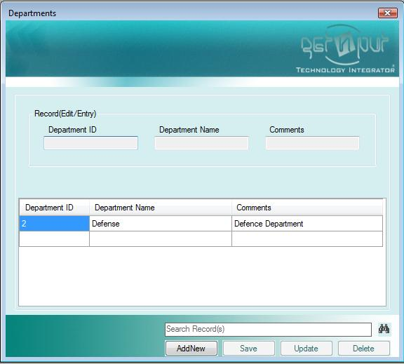

**Status Form:**

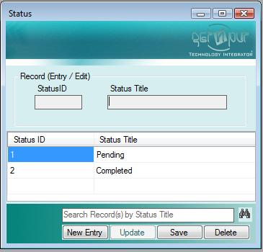

**Daily Agenda Form:**

The insert, Update, and Delete functionality of this form is also same to the above forms, but extra functionality to this form is showing the view of the text boxes like the “Text in Pashto” and “Text in Dari” by clicking on the button having text “……” after each Text box. When you click on the button “……” after the Text in Pashto text box a new form View is open which show the text of the Text in Pashto text box. Now if you make changes in the View form and press ok button the text will be automatically copied here. The same procedure is for Text in Dari text box. All the other functionality is same as discuss above. The screen shot of this form is below.

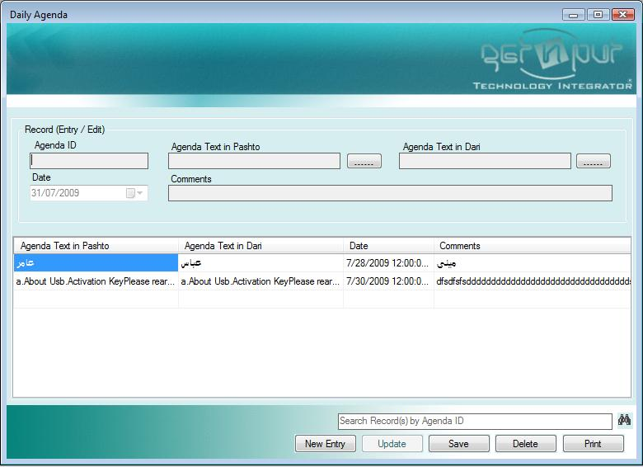

If you want to print daily Agenda press on the print button the following interface will appears. Select the date of Agenda and press the print button. Report of the mention date Agenda will be shown and ready for Print.

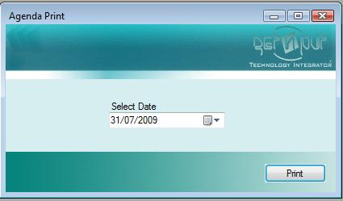

**Resolution Form:**

To operate this form is same that of the Daily Agenda. A look of this form is given below.

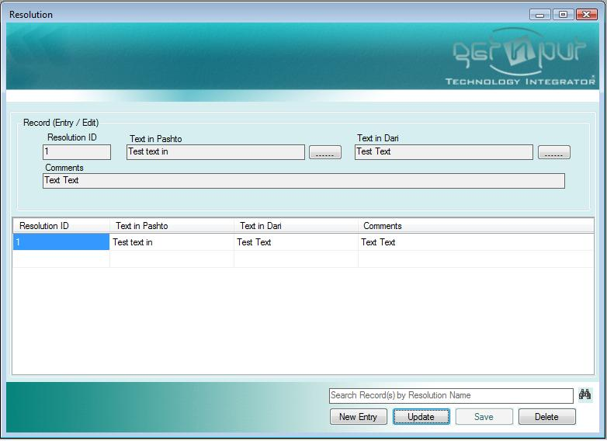

**Members, User Accounts, User Group Forms:**

In these forms if you want to insert new record first select New Entry button, make entries and then press save button. Make sure that the input data provided is accurate and then press the save button. When the “Record Inserted” message appears it mean your record is inserted successfully and it will be shown in the list. Now if you want to update or delete a record first select it from the list in case of update make changes and presses Update button while in case of delete press the Delete button. Similarly to search a record enters the parameter in the search Record field and presses enter. Your desired record will be displayed in the list.

In case of User Account form user group and Status must be entered. The Screen shots of these forms are given below.

**Member Form:**

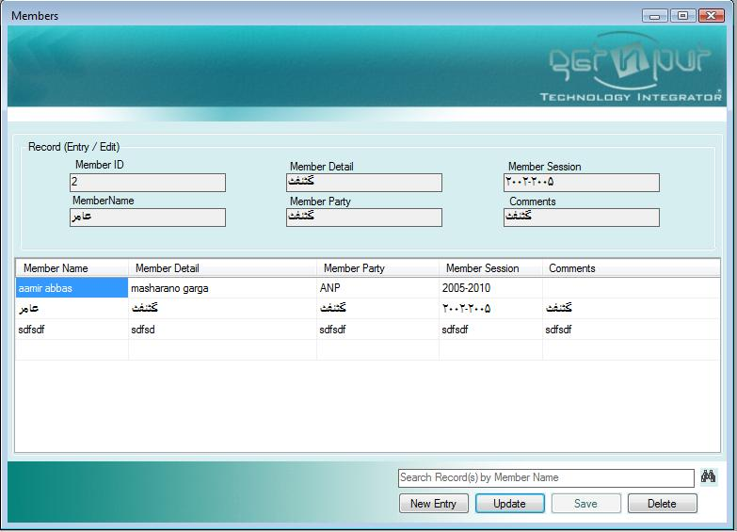

**User Account Form:**

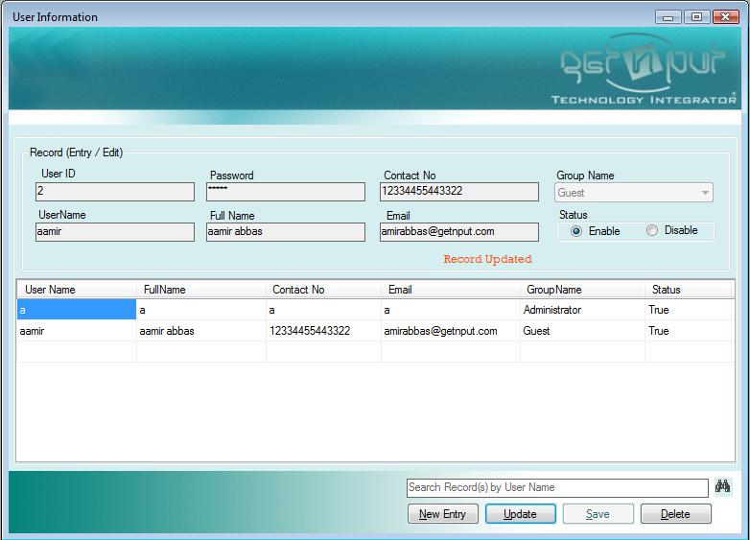

**User Group Form:**

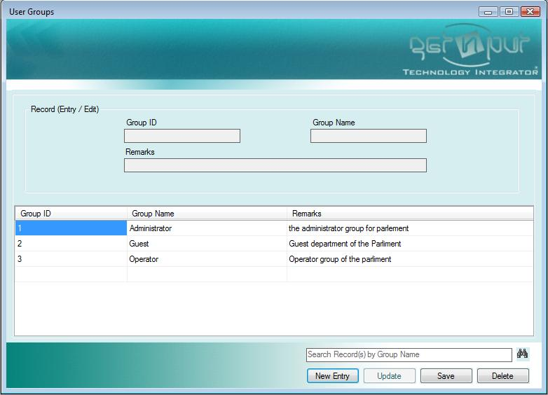

**Group Rights Form:**

This form is used by the Administrator to set rights for the User Groups. To give rights to a group first of all select the group from combo box and then use the shot cut keys i.e. allow all, deny all, Normal or check the appropriate check box that if u want to visible or invisible for example if u want that the user of this group have able to see the setup menu so select that group and then check the Setup check box and press save if it is first time otherwise press Update button.

It is to be noted that no one can change the rights of the Administrator group nor delete it.

To add rights select the group and then give right and press save button. Now if you want to update the right first select group make changes and then press Update button. Similarly to delete press the Delete button.

A look of the form is given below.

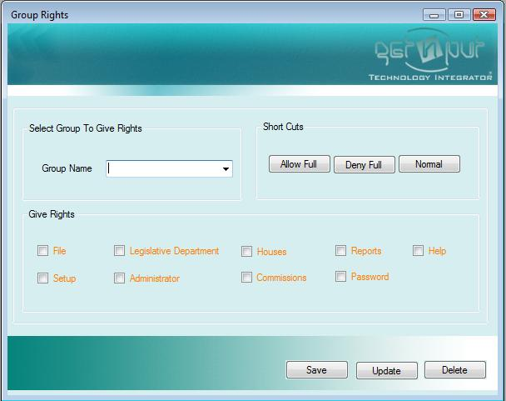

**Reset Password For Any User:**

This form is used to set password of any user. This form is used by the Administrator group only. To reset the password enter the user name and the new password and press the Reset Password button. Password will be updated.

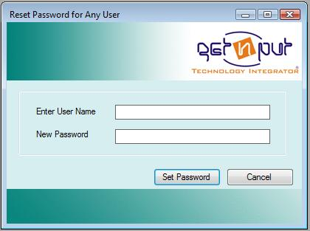

**Set password Interface:**

This form is used to by any user to reset his password only. If user wants to change the password he must enter his old password and enter the new password, and confirm password. Make sure that the new password and Conform password must same. And in last press the set Password button. The Screen shot of this form is below.

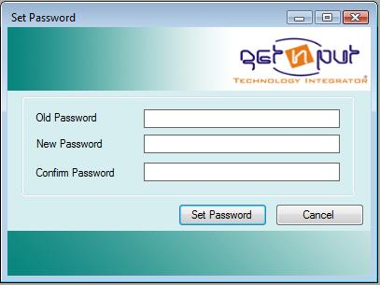

**Bill Form:**

This form is used to enter the bill to the database. To add new bill first of all enter the New Entry button. And then enter the bill title, bill number, bill text etc. if you want to see the detail of the Text in Pashto and want to show the detail of the text click on the button having text “……”, similarly for Text in Dari. One radio button from Members or Department is selected. If you check the Department radio button then mention the department from combo. While in case of Member radio button first save the record and then to add member to that new saved bill select it from list and then select the member from the member list and press Add Member button. The second list of member shows that member which is added to the bill. If you want to delete a member so select it from the second list and press Delete Member button. Member will be deleted from the selected bill. It is to be noted that in case of member addition to bill first save the bill and then select that newly entered bill and then add member while in case of department the department is added in the first go to press the save button. To make changes to the existing bill first of all select the desired bill from the bill list, make changes and then press the save button. Keep in mind if you change the existing bill by changing the member to department, or department to member you must follow the same procedure as discuss above. To delete a bill first of all select it from the list and press the delete button. But only that bill will be deleted which is not forwarded to house or Commission. In case if it is forwarded so first of all you delete it from that house or commission and then delete from here. After each operation see the message whether it display the correct message or producing the error message. In case if error message appears it means that you not follow the correct flow of Procedure. A look of this form is given below. Incase if you want to save .doc or .Pdf file of bill just click on the Upload file select the file and then save it. Incase if you want to download a bill select the record from the list and press the Download file it open that file. Now you can save it where you want. Download is only possible if a file is uploaded.

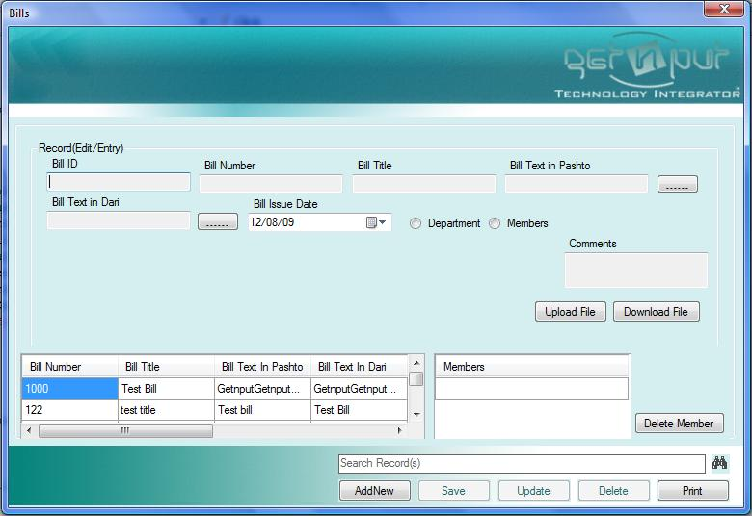

If you want to print a record so press on the print button. Another form is open given below.

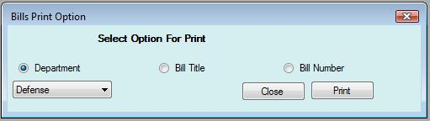

Here you select the option I.e. if you want to print the bills of a department so select the department radio button and then select the department and press on Print button the desired report will be displayed. Same if you print bill by Bill Title or Bill number give the Title or Number and press the Print button.

**Forward Bill to House Form:**

This form is used to forward a bill to house. First of all search the bill by giving the right keyword in the search bill field. Different bill will be appear in the list, select your desire one and click on it then select the House to whom you forward the bill enter dates and select status and press the Save/Forward button bill will be added to that house. And will be shown in the list. If you want to update a record select it from the list make changes and press the Update button. Similarly if you want to delete select and Press delete button. Keep in mind that the right message appears. Otherwise there is some mistake in your operation try again. Similarly if you want to search an existing record enter the bill title in the below search record field and press the Enter key, you desire record is shown in the list. Also note that bill is only forwarded by the Administrator / Legislative department group user. Other user can only update his status. The screen shot of Forward Bill to House Form is below.

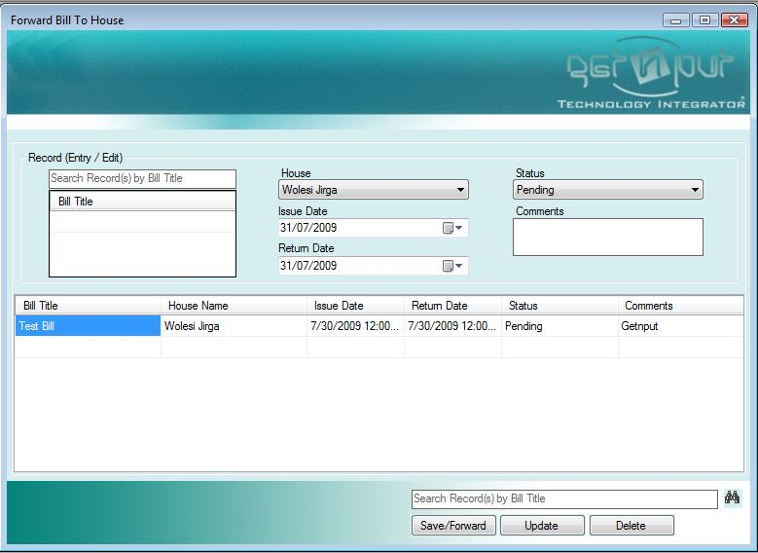

**Forward Bill to Commission:**

This form is used to forward bill to commission. To operate this form is exactly same to the above Forward Bill to House form. But only difference is that here you select the Commission instead of Bill. A look of this form is given below.

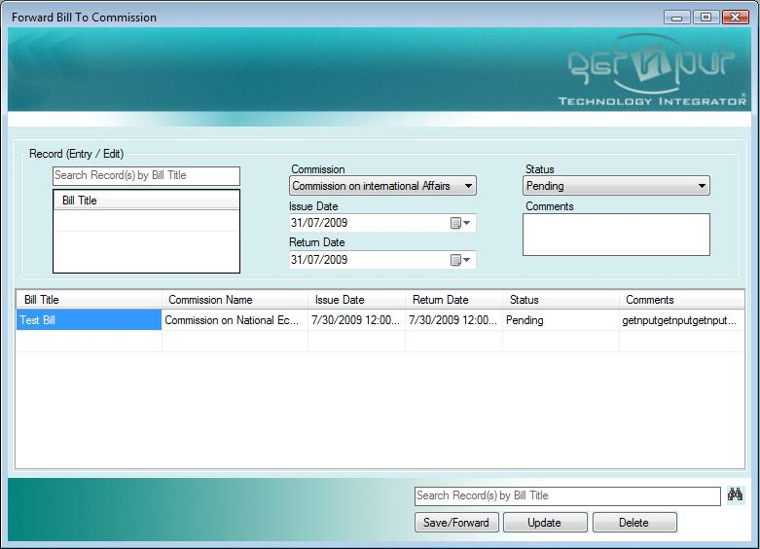

**Bill Tracker Form:**

This form is design to show the position of the bill. To see the position of a bill first of all search bill by title. And then select a bill from the filtered bill. Now if you want to see the current position or last bill is forwarded check the current position radio button. Current or last movement of the bill is shown in the list. But if you want to see the overall flow or the bill passes through check the Overall Flow radio button. The complete flow will be shown in the below list. If you want to print the bill position so select you desired radio button (Current Position, Overall Flow) and click on the Print button. your desired report will be shown. A look of this form is shown below.

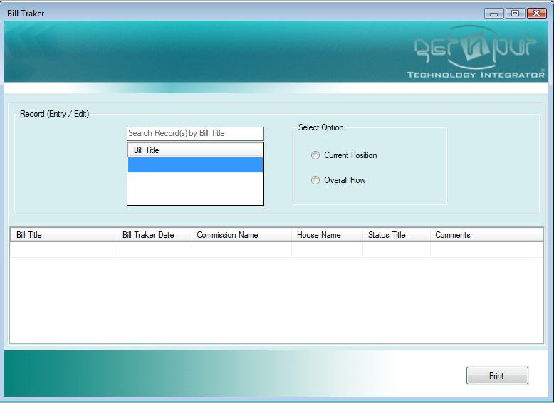

**Bill Amendments Form:**

This form is used to add amendments to the bill by the commissions or houses. To add amendments to a bill first of all press the New Entry button then search bill and select the searched bill from the list. Then make entries and then press the Save button. If “Record inserted” appears it mean that amendments is added. And it will be shown in the list. It is to be noted if you want to see the detail of the Text in Pashto or Text in Dari click on button having text “…..” After each field it will show the detail of your desired text field.

If you want to update a record select it from the list, make changes and press the Update button. Similarly if you want to delete a record select from list and press the Delete button. To search a record enters the bill title in the search field at the bottom of the page and press Enter button. Your desired record is shown in the list. A look of this form is given below.

